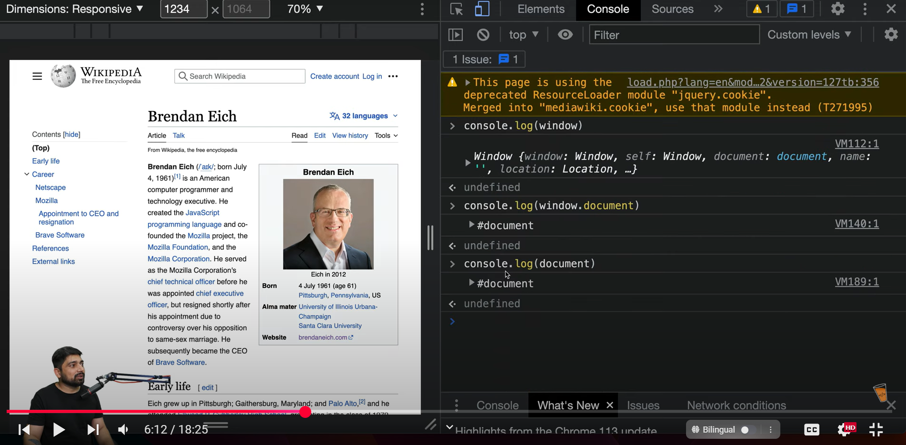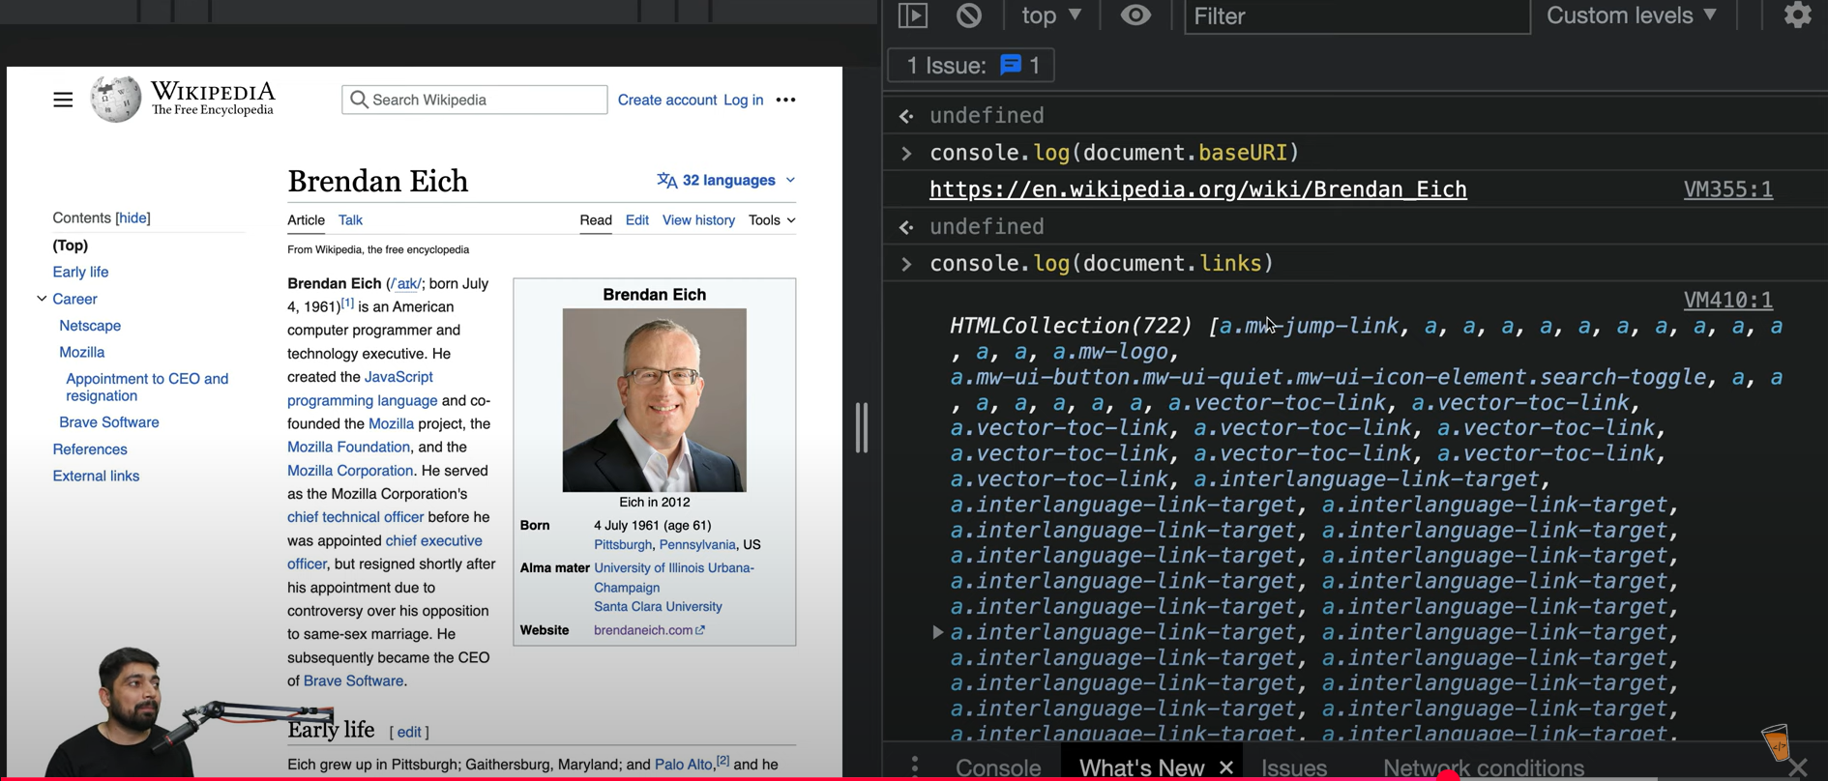

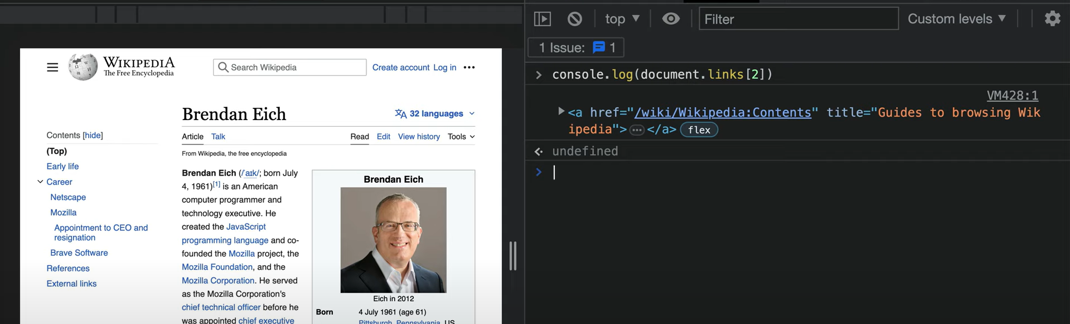

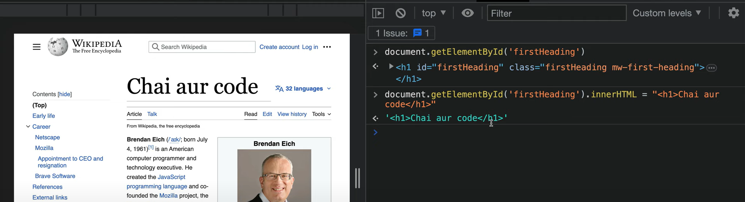

Video 32 started:

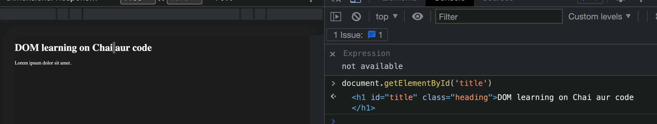

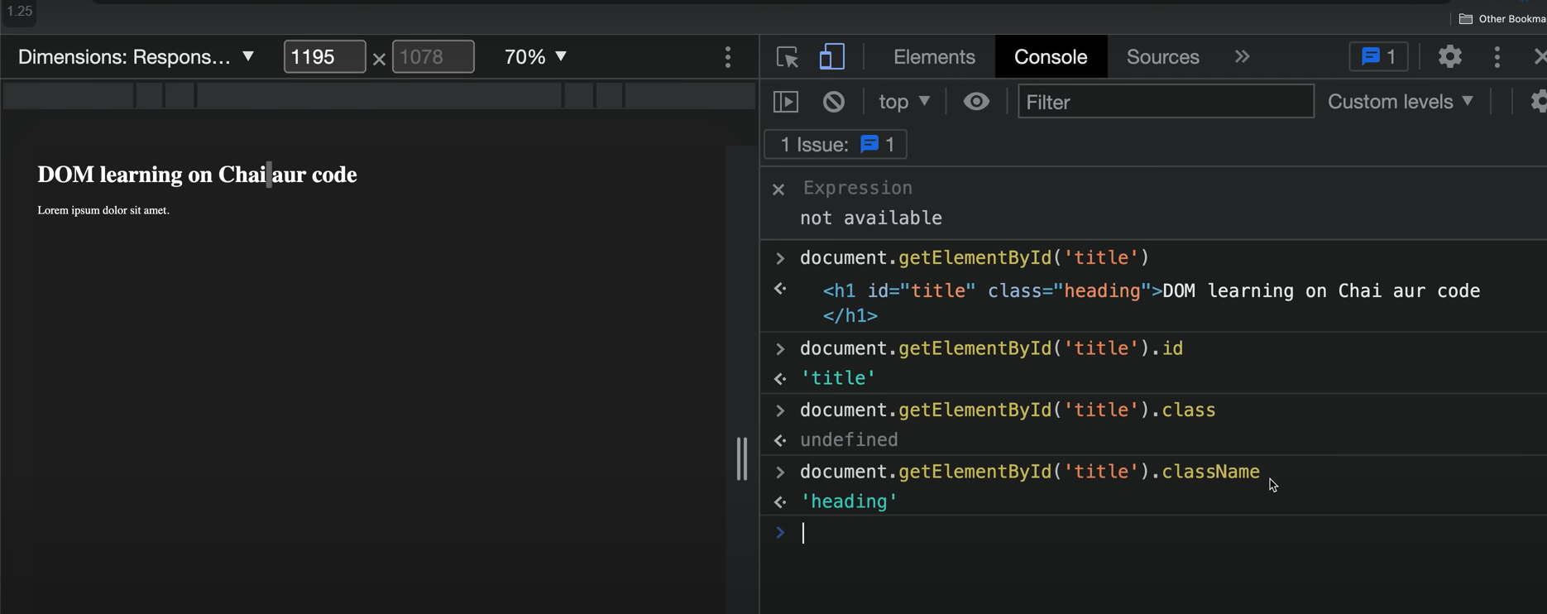

DOM ke andar className refer krte ha class ko always

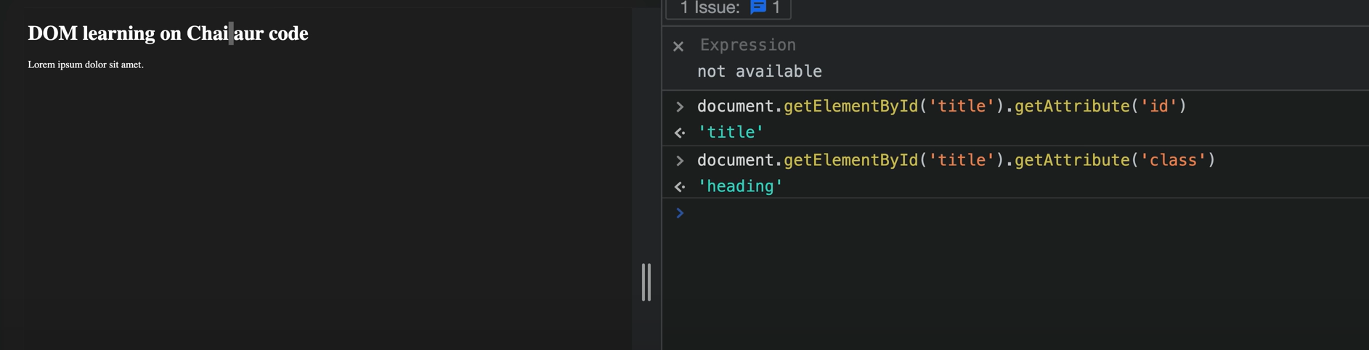

To get the attributes, pass the key to get the corres. Values

We can also set attributes:

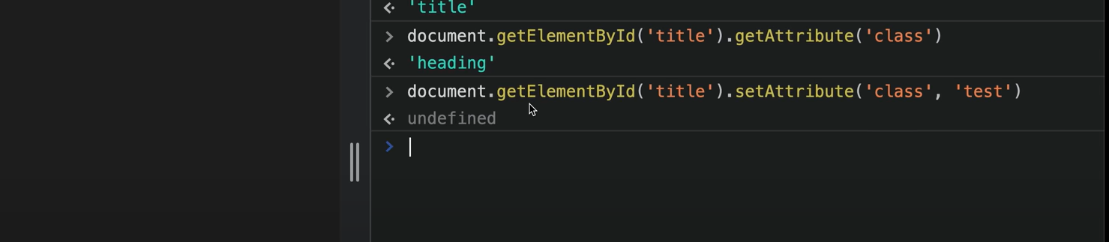



SetAttribute will overwrite the older values

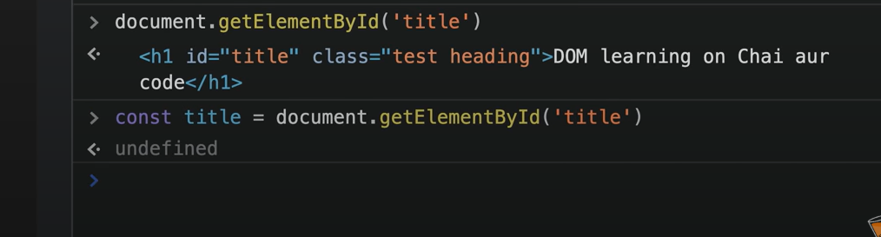

Applying style through dom:

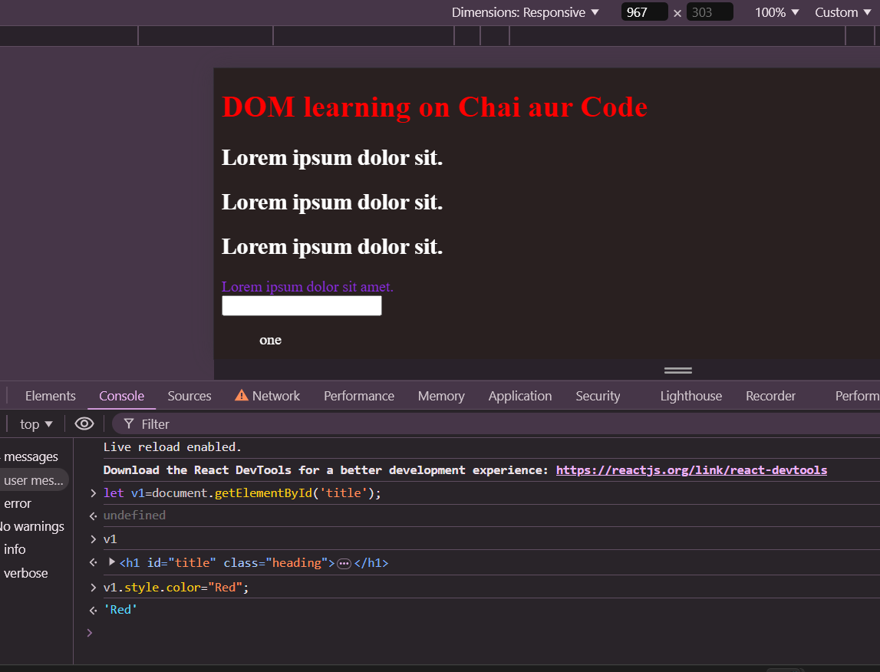

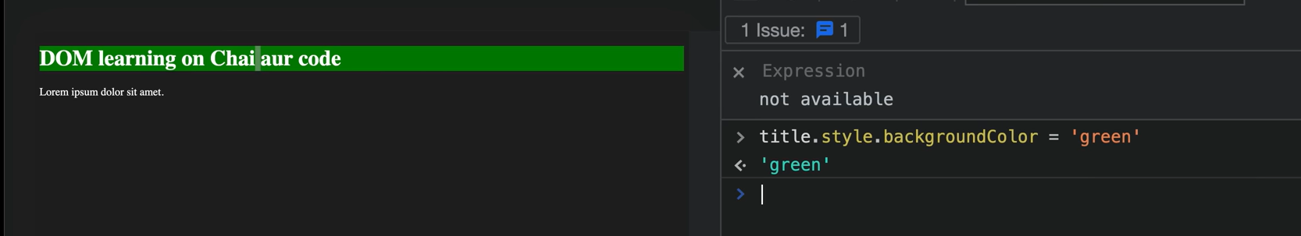

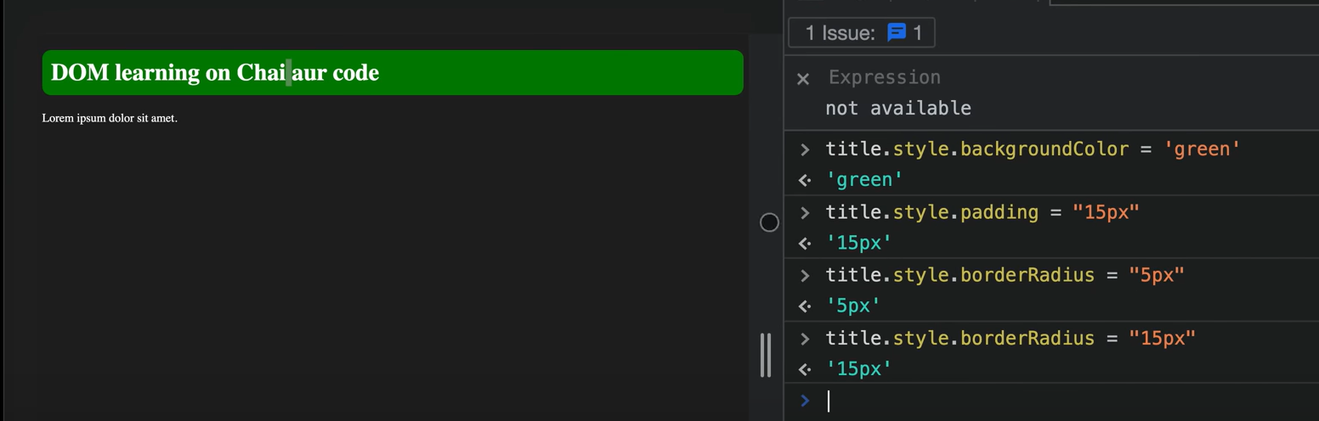

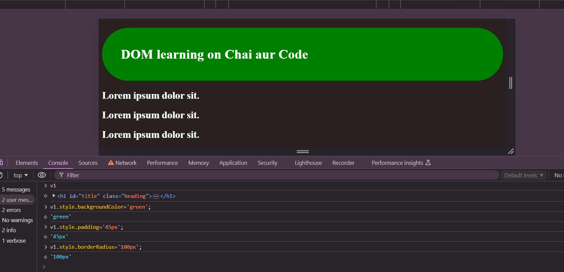

How to extract content?

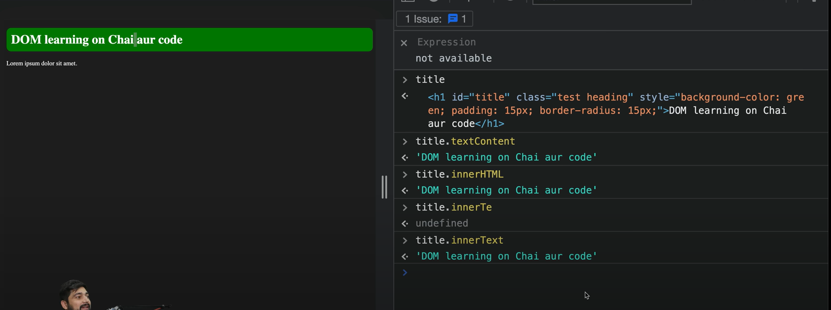

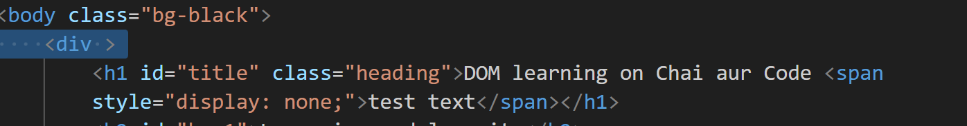

Display : none -> CSS property applied

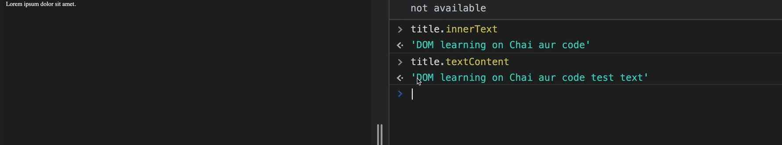

textContent also showed up hidden content

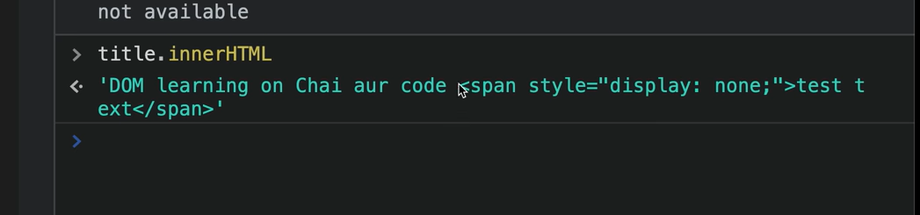innerHTML html value tags bhi de deta ha…baki 2 html tags ko support nhi krta

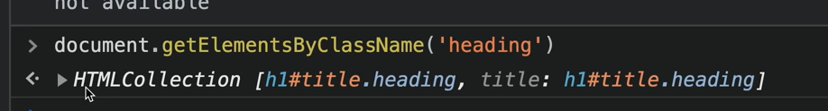

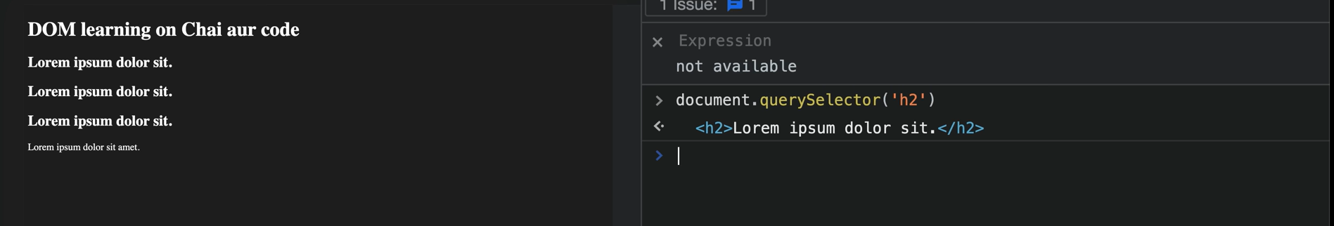

Query selector bas first h2 tag select krke dega

* To select id use # in queryselector

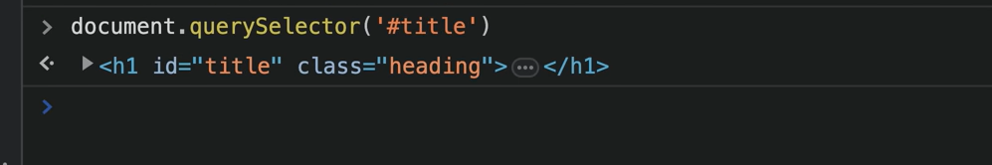

* To select class:

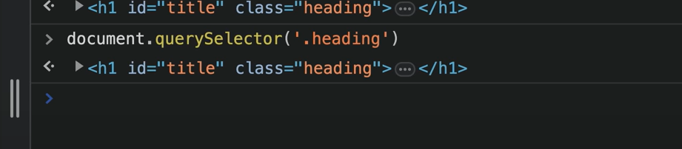

* All CSS selectors are supported in query selector:

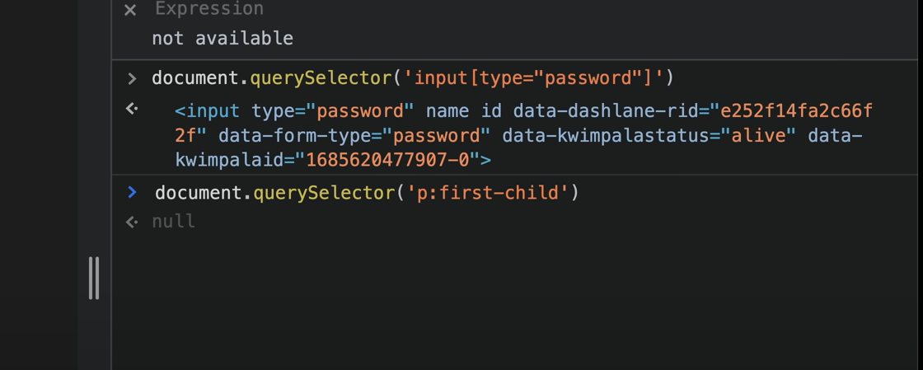

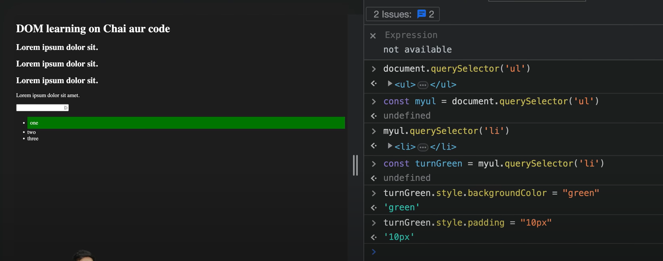

In above we have styled first list item

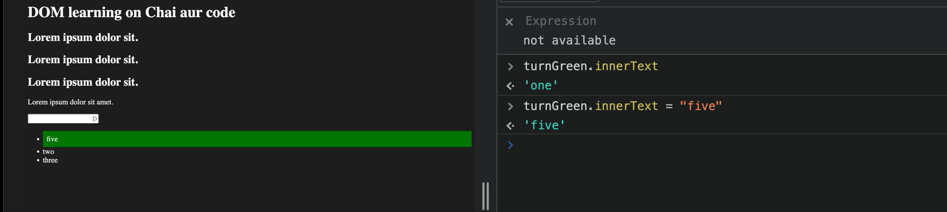

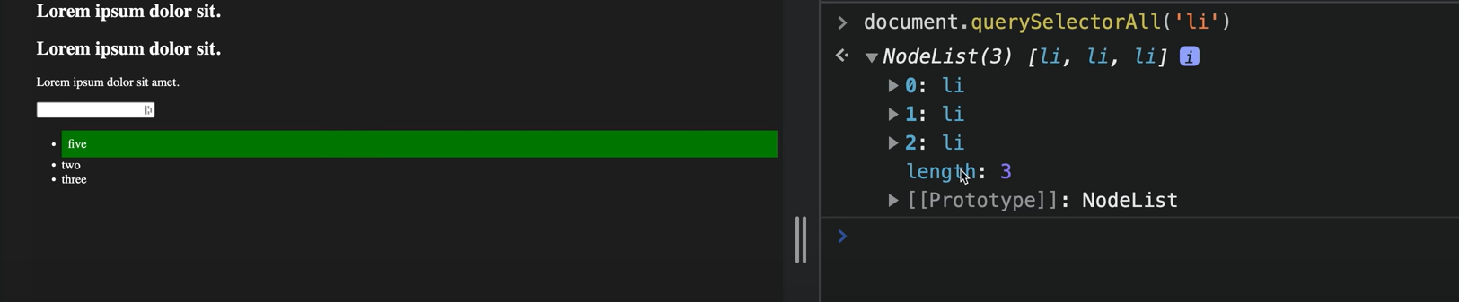

querySelectorAll returns node list

node list is not pure arrays…so all properties of arrays are not applicable to them

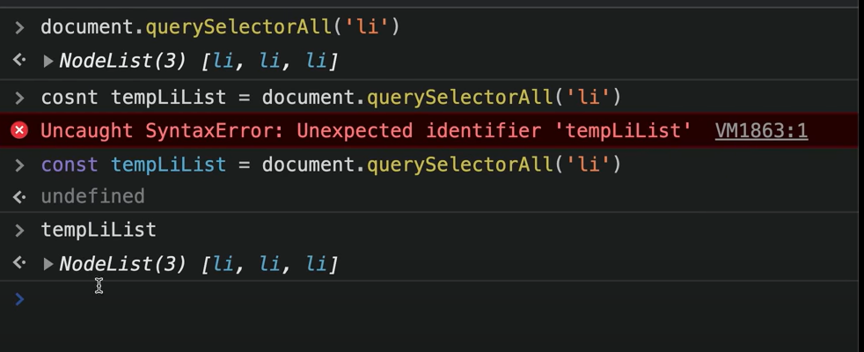

Prototype me jo fxns defined kisi elmnt ke only those can be applied

Coloring first elmnt using nodelist:

Nodelist me indexes has to be given for applying styling to elmnts

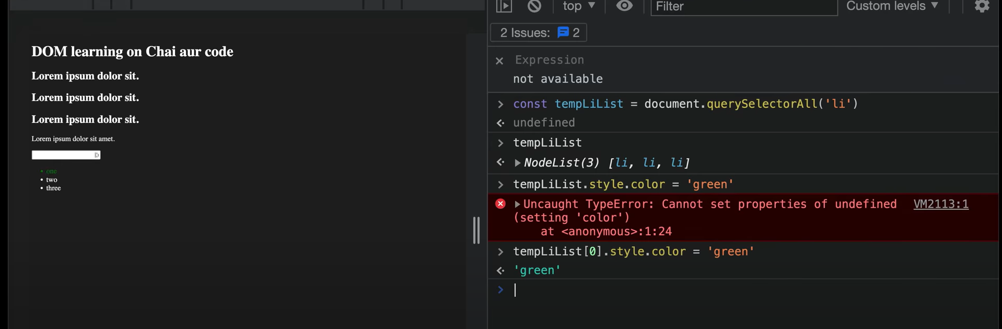

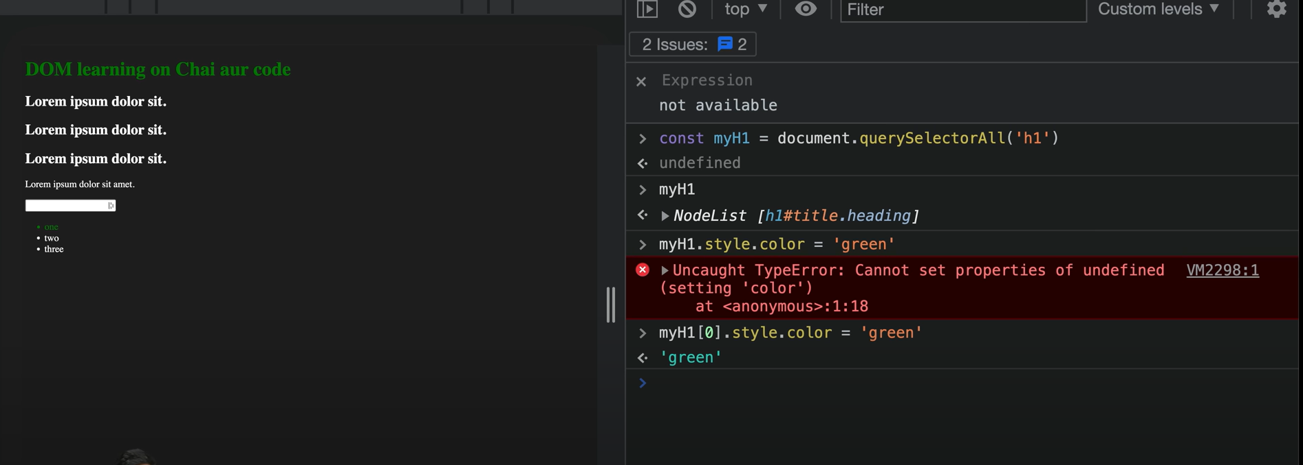

Using forEach loop in nodelist to style all list elmnts:

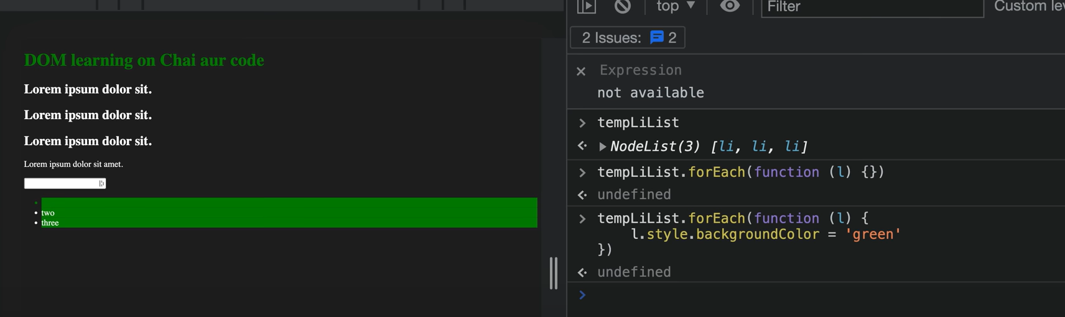

--

To use fxns like map etc on nodelist , first convert it to arrays

Note: HTML collections are diff. from nodeList.

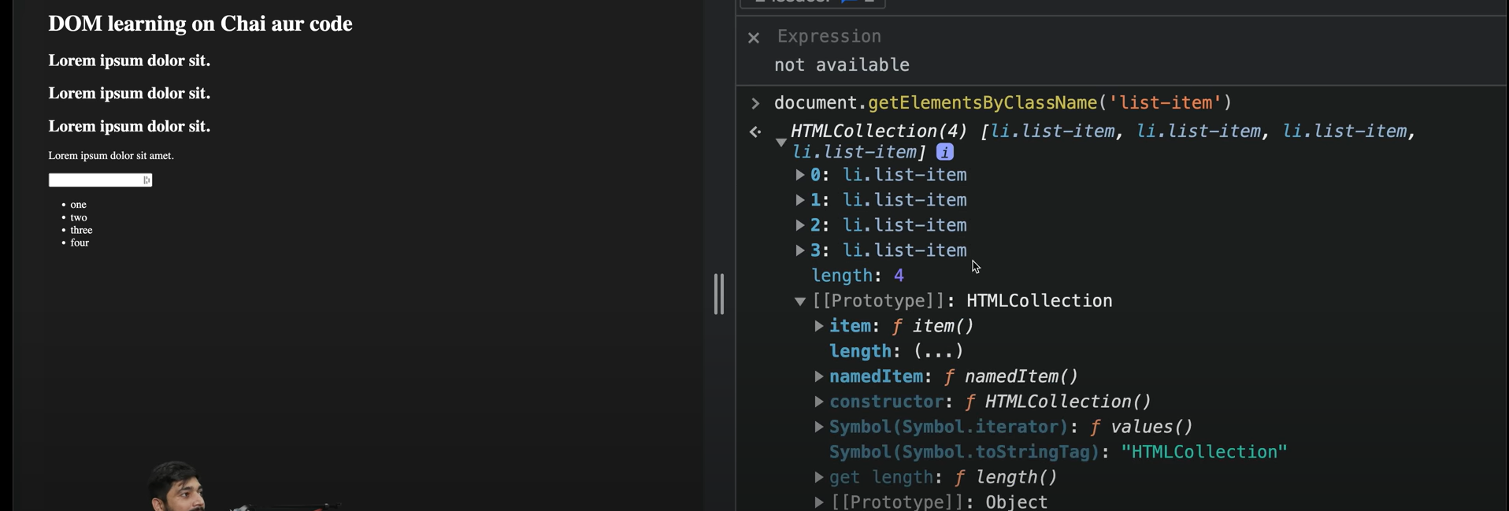

HTML collections have no option for looping

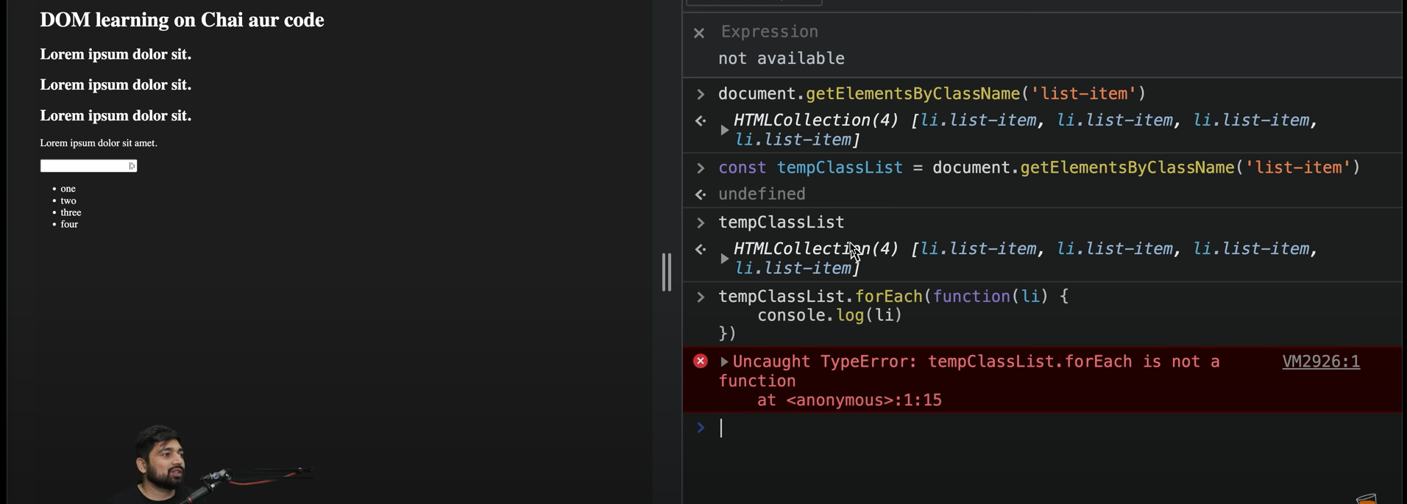

So we have to convert HTML collections to arrays to apply looping

Array.from() method can be used: kaha se mai array me convert kru

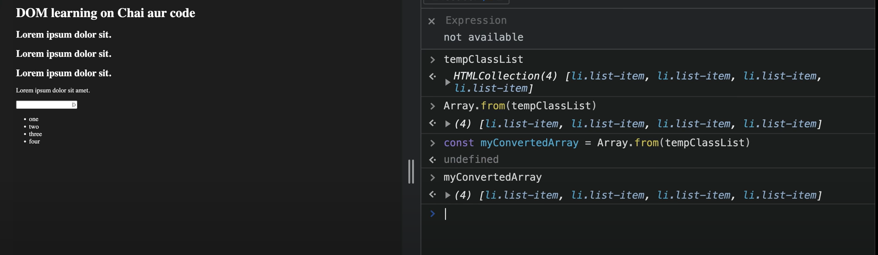

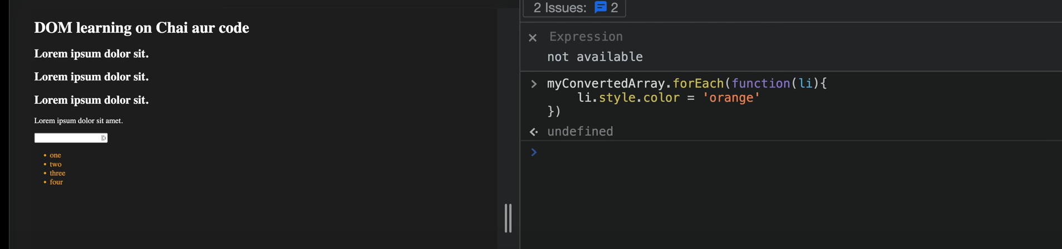

Doing fun on JS website:

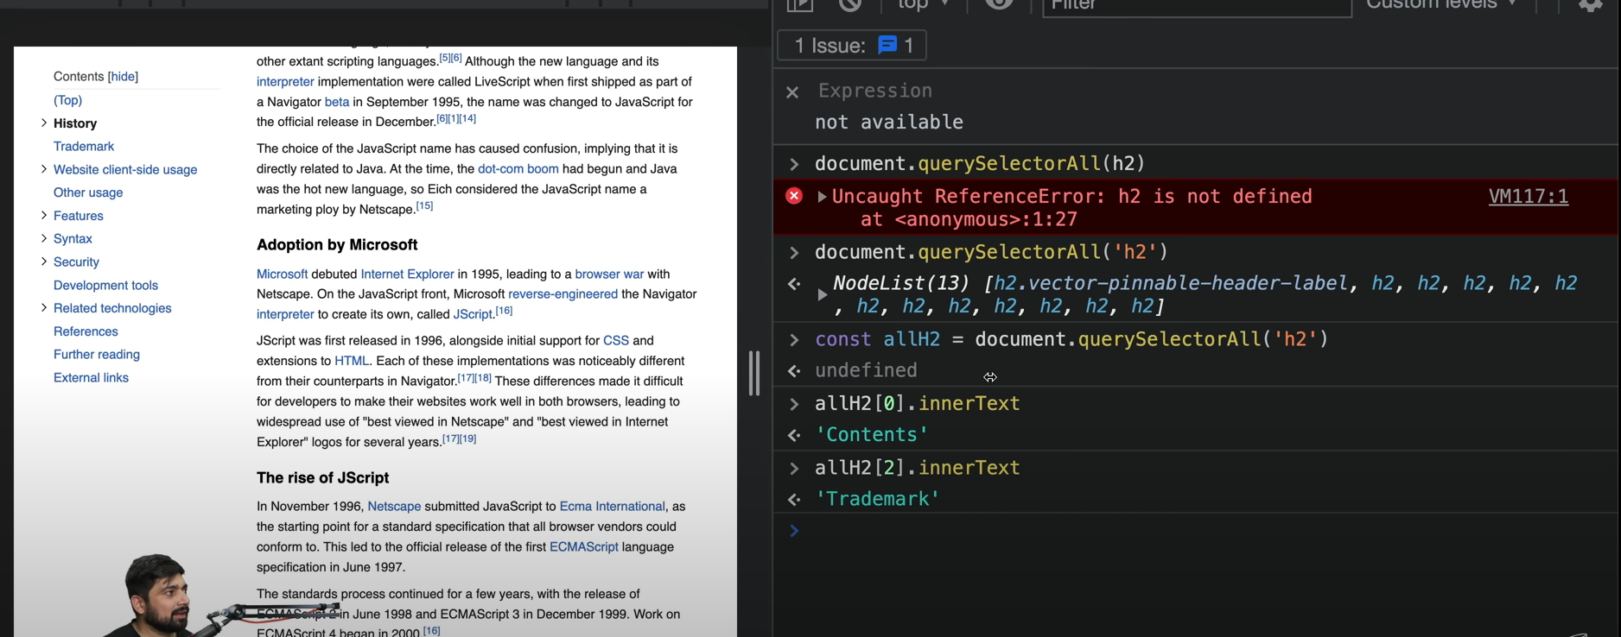

2.

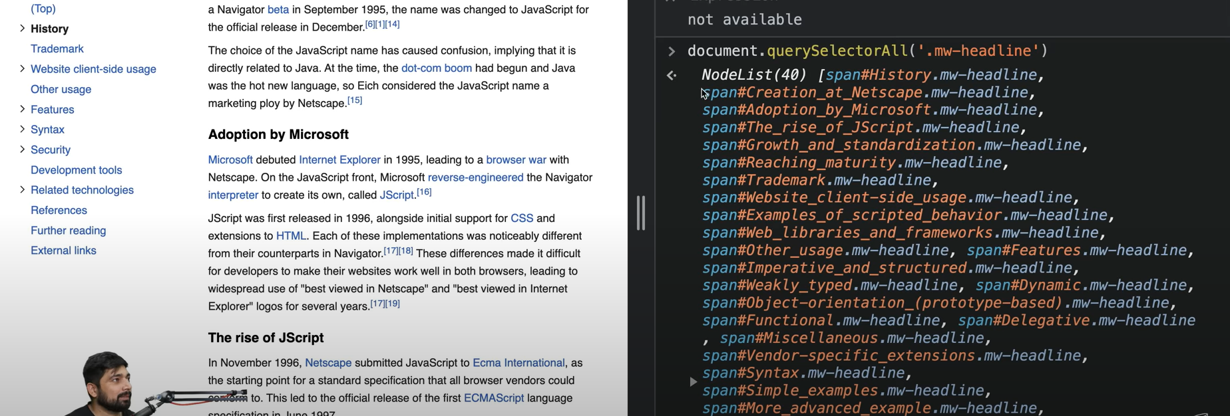

3.

